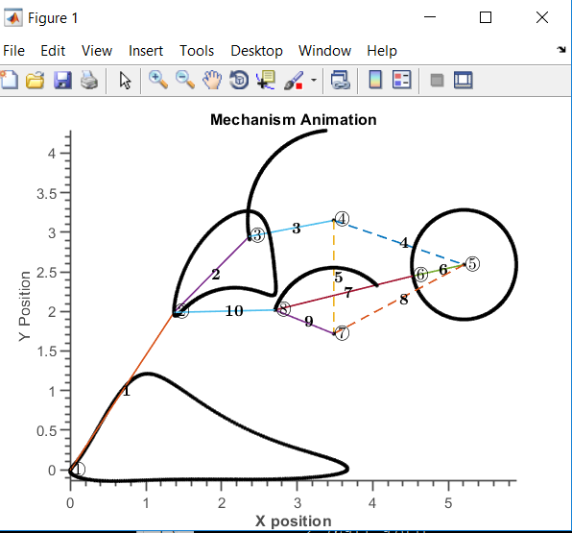

**Links given in bold**

**For link 1 the distance must be from the centre to the tip and not centre to centre**

**The rest of the distances are centre to centre**

**Angle between 1 and 2 is 168.5**

**Angle between 7 and 10 is 167.5**

1: 2.42140121532466

2: 1.38023809721932

3: 1.13962448109588

4: 1.81253639325994

5: 1.43232704402516

6: 0.691871010402804

7: 1.87518990243838

8: 1.93209807786172

9: 0.834249426450987

10: 1.33627375428043

**Comments:**

* Not much change apart for legs and ground links, but I think our current lengths exceed 4 inches by a huge margin. These lengths should make the robot’s within 4 inches(Including the links widths and stuff.
* The stride length is 3.5 inch do we need to hit only 12 revs a minute to hit the desired speed.